**Laporan Resmi**

**Praktikum Algoritma dan Struktur Data**

**Review array, pointer, struct** 

**Dr. Tita Karlita S.Kom, M.Kom**

**Nama : Marits Ikmal Yasin**

**Kelas : 1D4 IT B**

**NRP : 3121600047**

1. Soal Nomor 1

Code :

#include<stdio.h>

#define MAKS 25

struct nilai{

*float* tugas, uts, uas, akhir;

*char* grade;

};

struct student{

*char* nama[MAKS];

    struct nilai rapot;

};

*void* input(struct **student**[]);

*void* cek(struct **student**[]);

*void* tampil(struct **student**[]);

*int* jumlah_mhs;

*int* j;

*int* main(){

    struct student mhs[MAKS];

    input(mhs);

    cek(mhs);

    tampil(mhs);

}

*void* input(struct student **maha**[]){

*extern* *int* jumlah_mhs;

    printf("Berapa jumlah mahasiswa ? ");

    scanf("*%d*",**&**jumlah_mhs);

    puts("Masukkan DATA Mahasiswa\n");

**for**(j**=**0 ; j**<**jumlah_mhs ; j**++**){

        printf("Mahasiswa ke-*%d*\n",j**+**1);

        printf("Nama\t\t: ");

        fflush(stdin);

        gets(maha[j].*nama*);

        printf("Nilai Tugas\t: ");

        scanf("*%f*",**&**maha[j].rapot.*tugas*);

        printf("Nilai UTS\t: ");

        scanf("*%f*",**&**maha[j].rapot.*uts*);

        printf("Nilai UAS\t: ");

        scanf("*%f*",**&**maha[j].rapot.*uas*);

    }

}

*void* cek(struct student **maha**[]){

**for**(j**=**0 ; j**<**jumlah_mhs ; j**++**){

        maha[j].rapot.*akhir* **=** 0.2 **\*** maha[j].rapot.*tugas* **+** 0.4 **\*** maha[j].rapot.*uts* **+** 0.4 **\*** maha[j].rapot.*uas*;

**if**(maha[j].rapot.*akhir* **>=** 80 **&&** maha[j].rapot.*akhir* **<=** 100)

            maha[j].rapot.*grade* **=** 'A';

**else** **if**(maha[j].rapot.*akhir* **>=** 70)

            maha[j].rapot.*grade* **=** 'B';

**else** **if**(maha[j].rapot.*akhir* **>=** 60)

            maha[j].rapot.*grade* **=** 'C';

**else** **if**(maha[j].rapot.*akhir* **>=** 50)

            maha[j].rapot.*grade* **=** 'D';

**else**

            maha[j].rapot.*grade* **=** 'E';

    }

}

*void* tampil(struct student **maha**[]){

    puts("\t\t\tDAFTAR NILAI");

    puts("\t\tMATAKULIAH KONSEP PEMROGRAMAN");

    puts("---------------------------------------------------------------------");

    puts("No\tNama\t\t\t\tNilai\t\t\tGrade");

    puts("\tMahasiswa\t\tTugas\tUTS\tUAS\tAkhir");

    puts("---------------------------------------------------------------------");

**for**(j**=**0 ; j**<**jumlah_mhs ; j**++**){

        printf("*%d*\t*%s*\t\t\t*%g*\t*%g*\t*%g*\t*%g*\t*%c*\n",j**+**1, maha[j].*nama*, maha[j].rapot.*tugas*,maha[j].rapot.*uts*, maha[j].rapot.*uas*, maha[j].rapot.*akhir*, maha[j].rapot.*grade*);

    }

    puts("---------------------------------------------------------------------\n");

    printf("Total Mahasiswa = *%d*\n", jumlah_mhs);

}

Output :

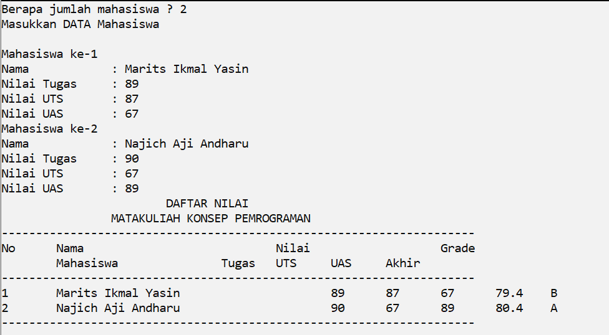

1. Soal Nomor 2

Code :

#include<stdio.h>

#define MAKS 25

typedef struct{

*int* tanggal, bulan, tahun;

}date;

typedef struct{

*int* id, gaji;

*char* nama[MAKS], jenis;

    date birthday ;

}pegawai;

*int*  n;

*void* input(pegawai **\***);

*void* tampil(pegawai **\***);

*int* main(){

    pegawai emp[MAKS];

    puts("\t\tDATA PEGAWAI\n");

    input(emp);

    tampil(emp);

**return** 0;

}

*void* input(pegawai **\*employee**){

   printf("Masukkan Jumlah Pegawai : ");

   scanf("*%d*",**&**n);

**for**(*int* i**=**0 ; i**<**n ; i**++**){

    employee -> *id* **=** i**+**1;

    printf("\nData Pegawai ke-*%d*\n",employee->*id*);

    printf("Nama\t\t\t : ");

    fflush(stdin);

    gets(employee -> *nama*);

    printf("Tgl Lahir (dd-mm-yyyy)\t : ");

    scanf("*%d*-*%d*-*%d*",**&**employee->birthday.*tanggal*, **&**employee->birthday.*bulan*, **&**employee -> *birthday*.tahun);

    fflush(stdin);

    printf("Jenis Kelamin (L/P)\t : ");

    employee -> *jenis* **=** getchar();

    printf("Gaji/bln\t\t : ");

    scanf("*%d*",**&**employee -> *gaji*);

    employee**++**;

   }

}

*void* tampil(pegawai **\*employees**){

    puts("\nData Pegawai yang telah diinputkan\n");

**for**(*int* i**=**0 ; i**<**n ; i**++**){

        printf("No id\t\t\t : *%d*\n",employees->*id*);

        printf("Nama\t\t\t : *%s*\n",employees->*nama*);

        printf("Tgl Lahir\t\t : *%d*-*%d*-*%d*\n",employees -> *birthday*.tanggal, employees -> *birthday*.bulan, employees -> *birthday*.tahun);

        printf("Jenis Kelamin\t\t : ");

**if**(employees->*jenis* **==** 'L' **||** employees->*jenis* **==** 'l')

            puts("Laki-laki");

**else**

            puts("Perempuan");

        printf("Gaji/bln\t\t : *%d*\n", employees->*gaji*);

        employees**++**;

        puts("");

   }

}

Output :

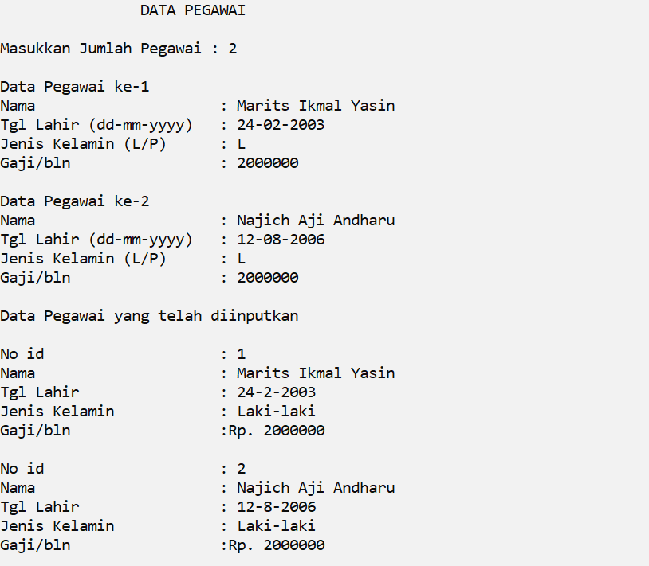

1. Soal Nomor 3

Code :

#include<stdio.h>

#define MAKS 25

typedef struct{

*float* tugas, uts, uas, akhir;

*char* grade;

}nilai;

typedef struct{

*char* nama[MAKS];

    nilai rapot;

}student;

*void* input(student **\***);

*void* cek(student **\***);

*void* tampil(student **\***);

*int* jumlah_mhs;

*int* j;

*int* main(){

    student mhs[MAKS];

    input(mhs);

    cek(mhs);

    tampil(mhs);

}

*void* input(student **\*maha**){

    printf("Berapa jumlah mahasiswa ? ");

    scanf("*%d*",**&**jumlah_mhs);

    puts("Masukkan DATA Mahasiswa\n");

**for**(j**=**0 ; j**<**jumlah_mhs ; j**++**){

        printf("Mahasiswa ke-*%d*\n",j**+**1);

        printf("Nama\t: ");

        fflush(stdin);

        gets(maha->*nama*);

        printf("Nilai Tugas\t: ");

        scanf("*%f*",**&**maha->rapot.*tugas*);

        printf("Nilai UTS\t: ");

        scanf("*%f*",**&**maha->rapot.*uts*);

        printf("Nilai UAS\t: ");

        scanf("*%f*",**&**maha->rapot.*uas*);

        maha**++**;

    }

}

*void* cek(student **\*maha**){

**for**(j**=**0 ; j**<**jumlah_mhs ; j**++**){

        maha->rapot.*akhir* **=** 0.2 **\*** maha->rapot.*tugas* **+** 0.4 **\*** maha->rapot.*uts* **+** 0.4 **\*** maha->rapot.*uas*;

**if**(maha->rapot.*akhir* **>=** 80 **&&** maha->rapot.*akhir* **<=** 100)

            maha->rapot.*grade* **=** 'A';

**else** **if**(maha->rapot.*akhir* **>=** 70)

            maha->rapot.*grade* **=** 'B';

**else** **if**(maha->rapot.*akhir* **>=** 60)

            maha->rapot.*grade* **=** 'C';

**else** **if**(maha->rapot.*akhir* **>=** 50)

            maha->rapot.*grade* **=** 'D';

**else**

            maha->rapot.*grade* **=** 'E';

        maha**++**;

    }

}

*void* tampil(student **\*maha**){

    puts("\t\t\tDAFTAR NILAI");

    puts("\t\tMATAKULIAH KONSEP PEMROGRAMAN");

    puts("---------------------------------------------------------------------");

    puts("No\tNama\t\t\t\tNilai\t\t\tGrade");

    puts("\tMahasiswa\t\tTugas\tUTS\tUAS\tAkhir");

    puts("---------------------------------------------------------------------");

**for**(j**=**0 ; j**<**jumlah_mhs ; j**++**){

        printf("*%d*\t*%s*\t\t\t*%g*\t*%g*\t*%g*\t*%g*\t*%c*\n",j**+**1, maha->*nama*, maha->rapot.*tugas*,maha->rapot.*uts*, maha->rapot.*uas*, maha->rapot.*akhir*, maha->rapot.*grade*);

        maha**++**;

    }

    puts("---------------------------------------------------------------------\n");

    printf("Total Mahasiswa = *%d*\n", jumlah_mhs);

}

Output :

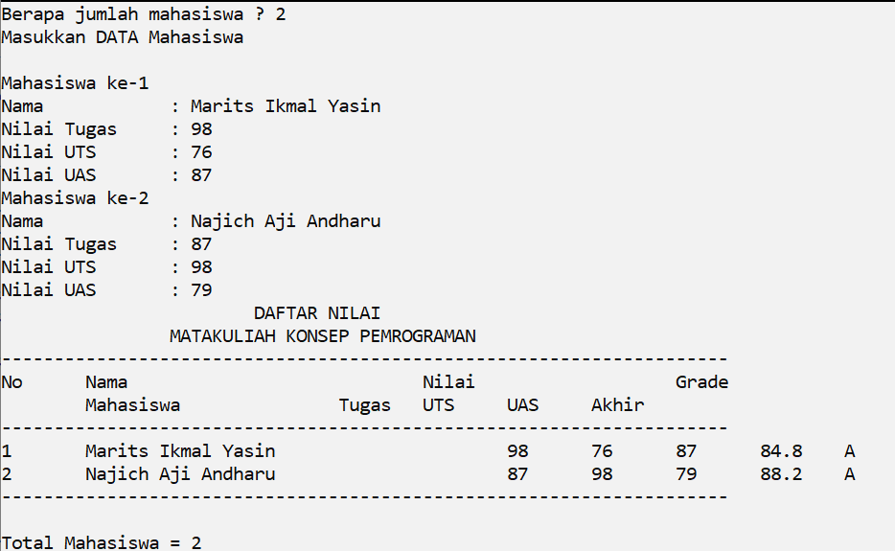

1. Soal Nomor 4

Code :

#include<stdio.h>

#define MAKS 25

#include<string.h>

typedef struct{

*float* tugas, uts, uas, akhir;

*char* grade;

}nilai;

typedef struct{

*char* nama[MAKS];

    nilai rapot;

}student;

typedef struct{

*char* nama[MAKS];

*float* nilai;

}maksimal;

*void* input(student **\***);

*void* cek(student **\***);

*void* tampil(student **\***, maksimal **\***);

*void* maks(student **\***, maksimal **\***);

*int* jumlah_mhs;

*int* j;

*int* main(){

    student mhs[MAKS];

    maksimal mha;

    input(mhs);

    cek(mhs);

    maks(mhs, **&**mha);

    tampil(mhs, **&**mha);

}

*void* input(student **\*maha**){

    printf("Berapa jumlah mahasiswa ? ");

    scanf("*%d*",**&**jumlah_mhs);

    puts("Masukkan DATA Mahasiswa\n");

**for**(j**=**0 ; j**<**jumlah_mhs ; j**++**){

        printf("Mahasiswa ke-*%d*\n",j**+**1);

        printf("Nama\t: ");

        fflush(stdin);

        gets(maha->*nama*);

        printf("Nilai Tugas\t: ");

        scanf("*%f*",**&**maha->rapot.*tugas*);

        printf("Nilai UTS\t: ");

        scanf("*%f*",**&**maha->rapot.*uts*);

        printf("Nilai UAS\t: ");

        scanf("*%f*",**&**maha->rapot.*uas*);

        maha**++**;

    }

}

*void* cek(student **\*maha**){

**for**(j**=**0 ; j**<**jumlah_mhs ; j**++**){

        maha->rapot.*akhir* **=** 0.2 **\*** maha->rapot.*tugas* **+** 0.4 **\*** maha->rapot.*uts* **+** 0.4 **\*** maha->rapot.*uas*;

**if**(maha->rapot.*akhir* **>=** 80 **&&** maha->rapot.*akhir* **<=** 100)

            maha->rapot.*grade* **=** 'A';

**else** **if**(maha->rapot.*akhir* **>=** 70)

            maha->rapot.*grade* **=** 'B';

**else** **if**(maha->rapot.*akhir* **>=** 60)

            maha->rapot.*grade* **=** 'C';

**else** **if**(maha->rapot.*akhir* **>=** 50)

            maha->rapot.*grade* **=** 'D';

**else**

            maha->rapot.*grade* **=** 'E';

        maha**++**;

    }

}

*void* tampil(student **\*maha**, maksimal **\*mahasiswa**){

    puts("\t\t\tDAFTAR NILAI");

    puts("\t\tMATAKULIAH KONSEP PEMROGRAMAN");

    puts("---------------------------------------------------------------------");

    puts("No\tNama\t\t\t\tNilai\t\t\tGrade");

    puts("\tMahasiswa\t\tTugas\tUTS\tUAS\tAkhir");

    puts("---------------------------------------------------------------------");

**for**(j**=**0 ; j**<**jumlah_mhs ; j**++**){

        printf("*%d*\t*%s*\t\t\t*%g*\t*%g*\t*%g*\t*%g*\t*%c*\n",j**+**1, maha->*nama*, maha->rapot.*tugas*,maha->rapot.*uts*, maha->rapot.*uas*, maha->rapot.*akhir*, maha->rapot.*grade*);

        maha**++**;

    }

    puts("---------------------------------------------------------------------\n");

    printf("Total Mahasiswa = *%d*\n", jumlah_mhs);

    printf("\nNilai Tertinggi\n");

    printf("Nama\t : *%s*\n",mahasiswa->*nama*);

    printf("Nilai\t : *%g*\n",mahasiswa->*nilai*);

}

*void* maks(student **\*mahasiswa**, maksimal **\*maksimum**){

**for**(j**=**0 ; j**<**jumlah_mhs ; j**++**){

**if**(mahasiswa->rapot.*akhir* **>** maksimum->*nilai* **||** j **==** 0){

            maksimum->*nilai* **=** mahasiswa->rapot.*akhir*;

            strcpy(maksimum->*nama*, mahasiswa->*nama*);

        }

            mahasiswa**++**;

    }

}

Output :

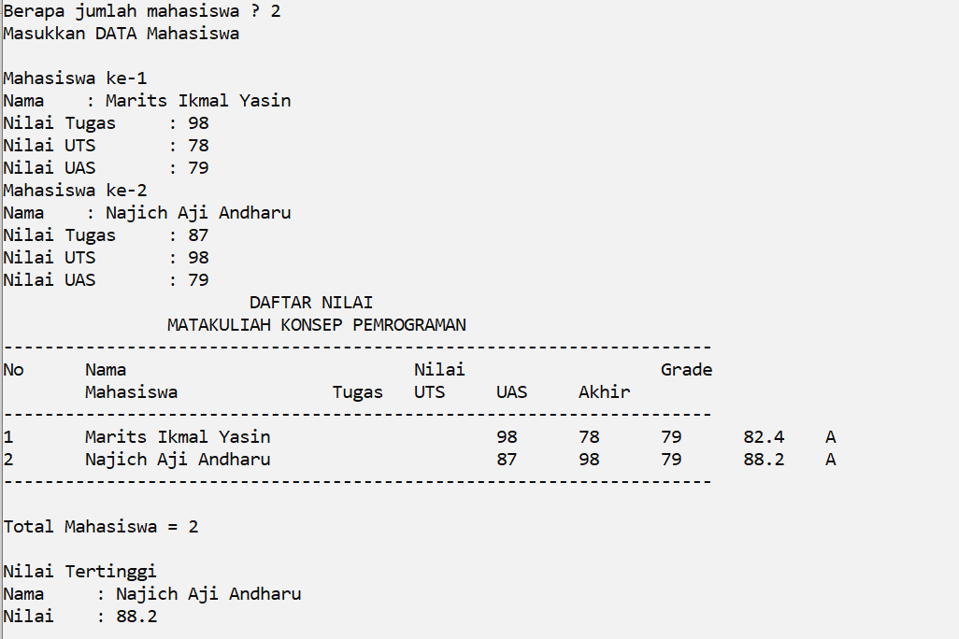

Analisa

Dari praktikum ini, kita mempelajari bagaimana penggunaan struct, typedef struct, dan juga pointer to struct. Kita bisa membedakan penggunaan array biasa dan juga pointer. Apabila kita menggunakan array maka kita mengakses data tersebut menggunakan indeksnya, tetapi apabila kita menggunakan pointer maka kita mengakses data dengan cara indirectly.